## Yogeek Shop Buy & Sell

#### Auto Translation.

Auto Translation functionality helps to automatic detect the language from UI and convert it as per user needed. For achive this goal we are planning to used below techniqs

**Deep Translate**

Deep Translate is an API based service provider which translating plain text and

HTML documents between any of 100+ supported languages. No limits on request number or document length! and its also cheaper than google translate.

and also its provide sandbox code of many languages.

**Pricing**

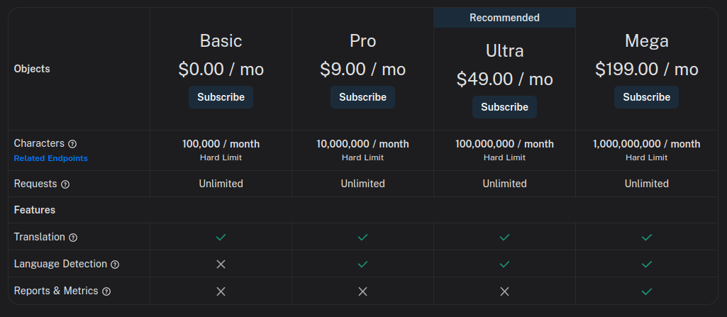

**Implementation flow**

**First we need to set a default language for our front store.**

For implement this we should follow **Store** concept in which we need to add language module with all its functions.

At the time of Signup we need to get users language by select or entering from user, and also stored this in **Store** also then we follow the language as default language of current user.

After that with the help of **Deep Translate** our language module’s function convert all the **UI**’s text to users default language.

And also we need to allow user to change his language through some where like setting or profie screen.

In **Chat** area we need to follow below steps

1. We need to get users message from there default language in chan area
2. By the help of our **language module**  we need to convert this to our **WebApplication’s**  default language
3. Then we need to stored this in **DB.**
4. At the time of message deliver we just need to convert the text from **DB** which is in set to our **WebApplication’s**  default language to the other users default language.
5. Using this techniqs we should mantain all text in one default language ( **WebApplication’s**  default language).